**Object-Oriented Software Engineering Project**

**Interim Project Report**

|  |  |
| --- | --- |
| **PROJECT TEAM** | |
| **Student No.** | **Student Names** |
|  | **Lorenzo Cipriani** |
|  | **Nassima Kara** |
|  | **Benjamin Adeline** |

**The Hunt of the Holy Grail in Ancient Egypt**

**31st March 2017**

# Background and scope of the project

The project is about the development of a strategy game with 3 different levels. The main character is a treasure hunter looking for the holy grail in the Ancient Egypt. The mission of the gamer is to use his logic to find the hidden treasure. To reach the top of the three levels, the gamer should adopt a strategy to override physical obstacles, take part into combats to move up from one level to another to increase his score and earn rewards to go through the challenges. “The Hunt of the Holy Grail in the Ancient Egypt” is a single player strategy game compatible with PC & mobile devices deployed via the cloud. The progress of the player through the levels and score is the result of a precise manipulation of the environment and choices he will make during his journey. In this interim report, we will review the software requirements specifications. In the first part, we demonstrate the story, levels, objects that will be used. Following the identification of the actors, we will have an overview of the game through a case diagram. In the second part, we will review the details of the use cases that are critical to the foundation of the game. Eventually we will establish the plan to build, test and deploy the application with key milestones.

## The identification of the actors

* **Story**

The game takes place in the Ancient Egypt, the player’s aim is to search for the Holy Grail. At the first level, he must choose three pyramids where he thinks that the Holy Grail is hidden:

- Pyramid of Khufu

- Pyramid of Giza

- Pyramid of Menkaure

Once the pyramids are chosen, the player should select the way he wants to reach these pyramids: by boat through the Nile or through the desert. If the player is choosing the travel by boat, he will face two challenges: the attack of crocodiles on the Nile and local nomads in an oasis if successful in the first test. If the player is successful, he should enter the pyramid and reach the tombs. If the player opts for the journey through the desert, he will face snakes. If successful, the player must defeat the spirit of Aladdin to be able to enter in one of the pyramids. In both scenarios, the player will be challenged by mummies, ghosts and the pharaoh in the tomb. The Holy Grail lies next to the tomb in one of these pyramids. When the player will reach the tomb, he will have a clue if the Holy Grail is not there and he should go to one of the two remaining pyramids. During his journey, his score will increase each time a battle is won and will move to the higher level once a certain level of score is reached. The score increase also means additional powers to face the future challenges.

* **User’ Interface**

At the start of the game, the player has the possibility to view the User Experience “Main Menu” that explain the purpose, content and controls of the game. The gamer can start playing or go to the level menu to select the desired level. The player can pause the game, restart or quit the game through the “game over menu”. If the player finishes the game and reach the next level, he will have the option to play at the new level or quit the game.

* **Hardware Interface**

As outlined earlier, the “Treasure Hunt in Ancient Egypt” should be supported by PC, web player, android phone, IOS. The game application will be stored in the game engine elements.

* **Software interface**

The tools used to develop the game are:

* Unity3D
* Autodesk Maya
* Autodesk 3ds Max
* Android Software Development Kit (Android SDK)
* **User’s characteristics**

The main actor in the game is the player who is interacting with the system by using any input through the keyboard. The primary requirement for the user is to authenticate himself at the start of the game.

# The Use case diagram

* **Overview of the game**

To have a global overview, we are using the scenario based model that is describing the requirements of the program.

**Use Case Diagram of the game “The Hunt of the Holy Grail in Ancient Egypt”**

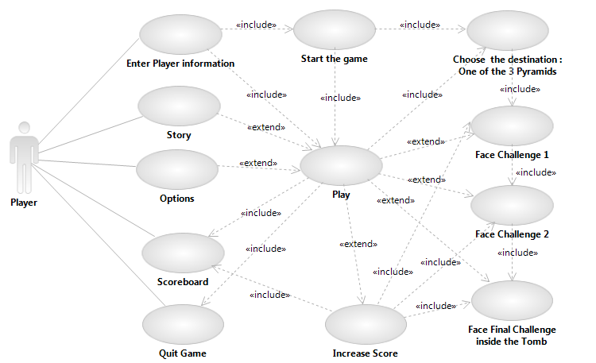

Use Case 1: Enter Player Information

Use Case 2: Story

Use Case 3: Options

Use Case 4: Choose destination (One of the three pyramids)

Use Case 5: Start the game, choose the itinerary (nile or desert)

Use Case 6: Play

Use Case 7: Face Challenge 1

Use Case 8: Face Challenge 2

Use Case 9: Face final challenge inside the tomb

Use Case 10: Increase the score

Use Case 11: Scoreboard

Use Case 12: Quit the game

* **Description of Use Case**

**Use Case 1: Flow Event for the Use Case “Enter the Player Information”**

Preconditions: None

Main Flow: As soon as the player enter in the User interface, the player information dialog will ask the player to enter his name

Subflows: None

Alternative Flows:

The name cannot be an empty string. If the player does not enter his name, the player information dialog will ask the name again

If the Quit button is pressed, the Player Information dialog closes and the game ends.

# The project development plan

The team defined the project scheduling as follows:

Create a Project Plan to deliver your application. The plan must include Project Scope based on a prioritized list of use cases, individual work-packages and all the major tasks and deliverables.

|  |  |
| --- | --- |
| Timeframe | Project Scope and Tasks |
|  | First meeting: definition of the proposal scope exploring different ideas |
|  | Second meeting:   * Building of the game story, brainstorming about the users’ characteristics and role. * Construct the Software Requirements Specification. * Discussion/Decision about the technologies that should be used in the software and hardware interface. |
|  | Third meeting:   * Identify the actors * Build the use case diagram * Flow of events for each use case in the Use-Case diagram |
|  | Fourth meeting: Developing the game for each scenario |
|  | Fifth meeting: Review of the individual progress |
|  | Sixth meeting: Review of the individual progress, target completion date |
|  | Seventh meeting: Review of the final work, testing |
|  | Eight meeting: Revision of the final report |
|  | Ninth meeting: Submission of the report |